**SMOKE VENTILTION EXHAUST FANS:**

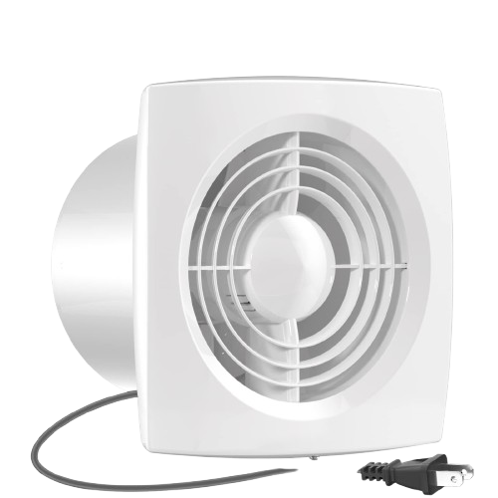

**Price: 4,300.00**

The Smoke Ventilation Exhaust Fan is a specialized ventilation solution designed to rapidly remove smoke, heat, and toxic gases from buildings in emergency situations. With its high-velocity airflow and durable construction, this fan provides critical ventilation support during fires, helping to reduce damage and promote safe evacuation. Its corrosion-resistant coating, thermal-resistant motor, and easy installation ensure reliable performance in extreme conditions, making it an essential component of any smoke ventilation system.

**Key features of smoke ventilation exhaust fans include:**

* **High Airflow Capacity:** Quickly removes smoke, hot gases, and fumes in case of fire.
* **Fire-Resistant Design:** Built to withstand high temperatures and operate during emergencies.
* **Powerful Motor:** Ensures efficient smoke extraction in critical situations.
* **Durable Construction:** Made with robust materials for reliable performance in harsh conditions.
* **Compliance with Safety Standards:** Meets fire safety regulations for building ventilation systems.
* **Energy Efficient:** Designed to consume less power while delivering effective smoke ventilation.
* **Quiet Operation:** Operates with minimal noise while ensuring maximum efficiency during an emergency.